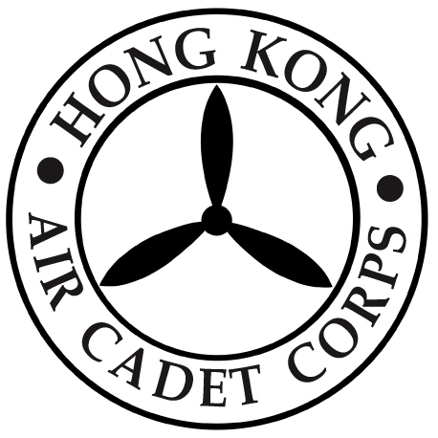

HONG KONG AIR CADET CORPS

From : HQ  Ref : GR20_001 | To : Unit Commanders  Cc : Major Unit Commanders
Tel : 2712 8900  Fax : 2715 6944 | Date: 2 January 2020

HQ Close Early on 24 January 2020

Please be informed that the Headquarters office will be closed early at 1300 hrs on the Chinese New Year’s Eve (24 January 2020).

Should you have any enquiry, please contact HQ staff by phone at 2712 8900 or by email to hq@aircadets.org.hk .

Megan TIN
Administrative Manager

